1. Open- https://start.spring.io/

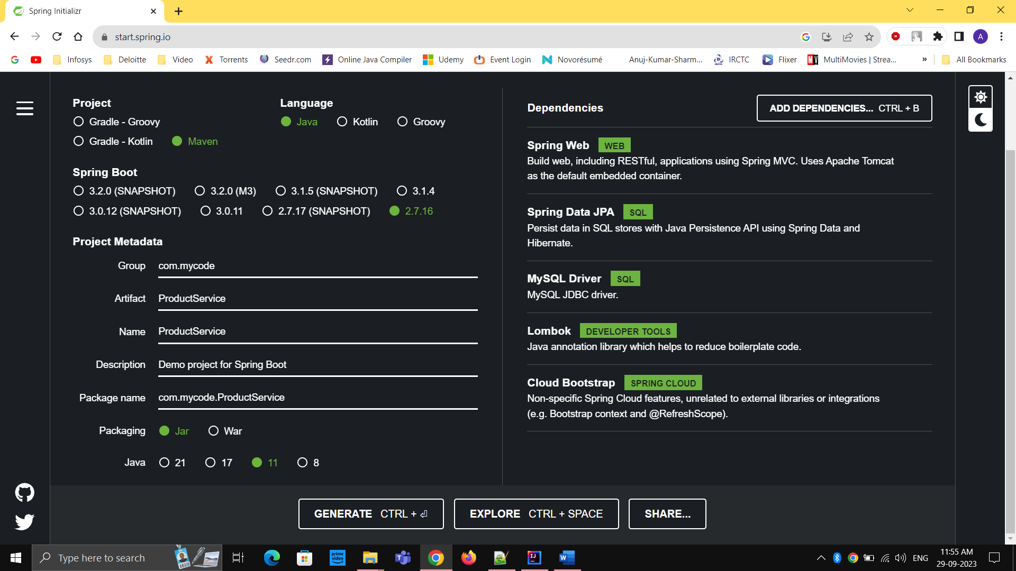

1. Application.yaml

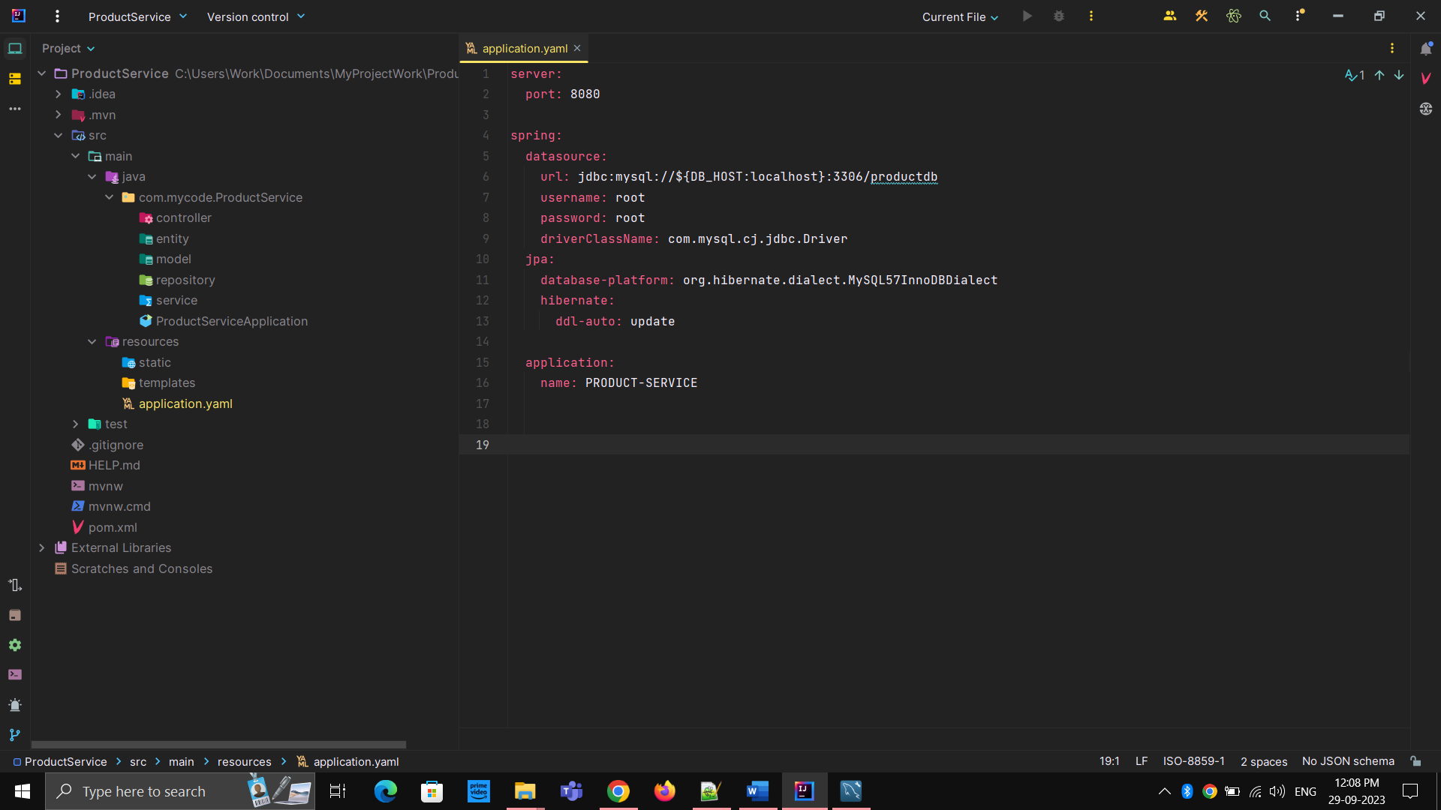

server:  
 port: 8080  
  
spring:  
 datasource:  
 url: jdbc:mysql://${DB_HOST:localhost}:3306/productdb  
 username: root  
 password: root  
 driverClassName: com.mysql.cj.jdbc.Driver  
 jpa:  
 database-platform: org.hibernate.dialect.MySQL57InnoDBDialect  
 hibernate:  
 ddl-auto: update  
  
 application:  
 name: PRODUCT-SERVICE

1. Product.java inside entity package

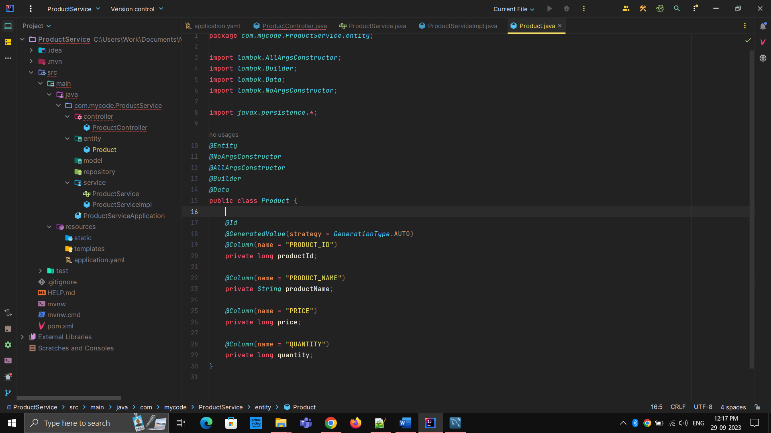

1. Create ProductRepository.java inside repository package

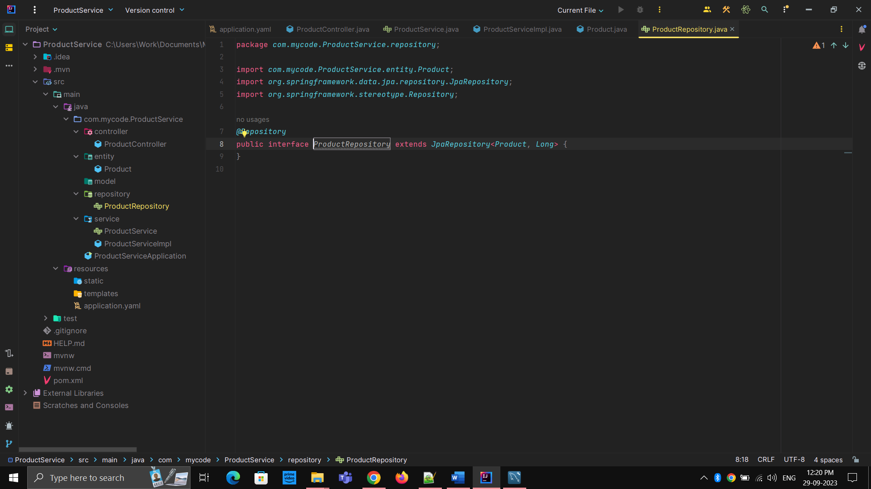

1. Create ProductController.java

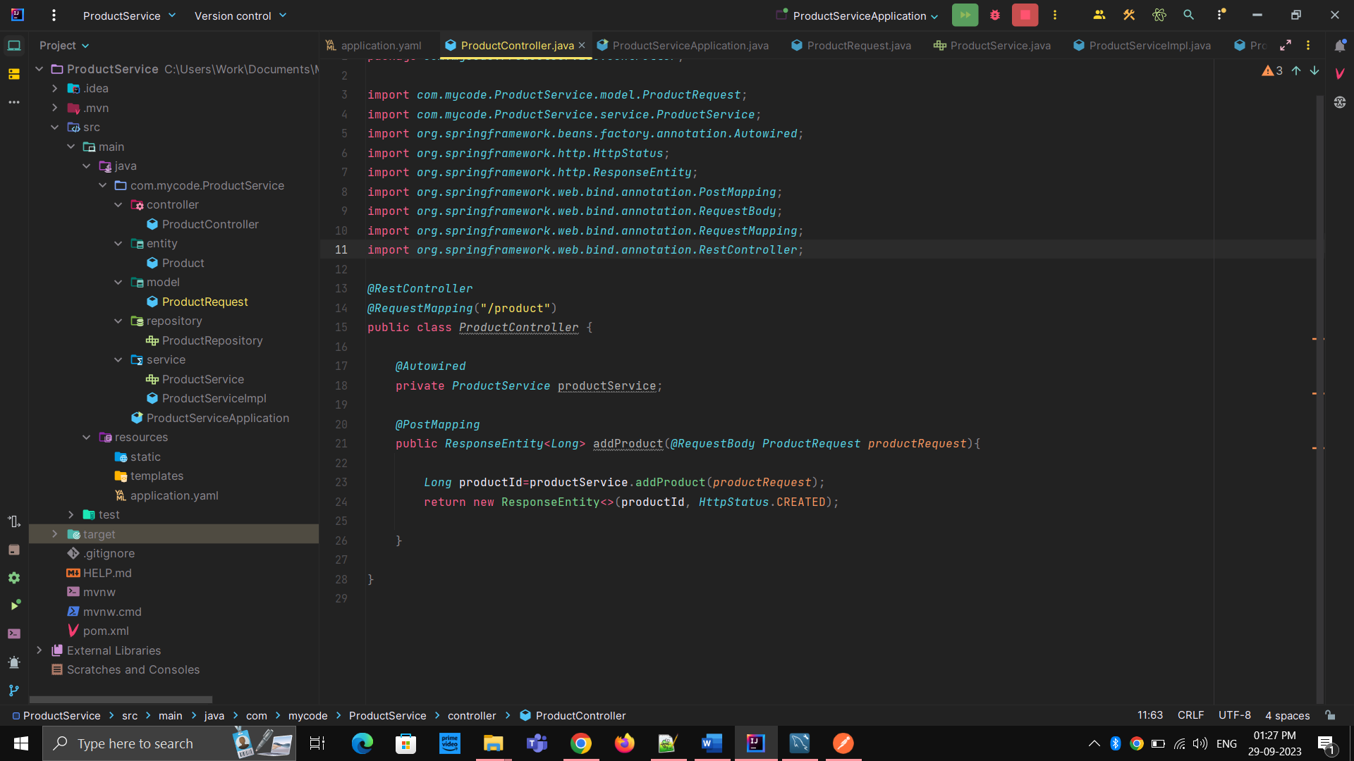

1. Create ProductRequest.java inside model package

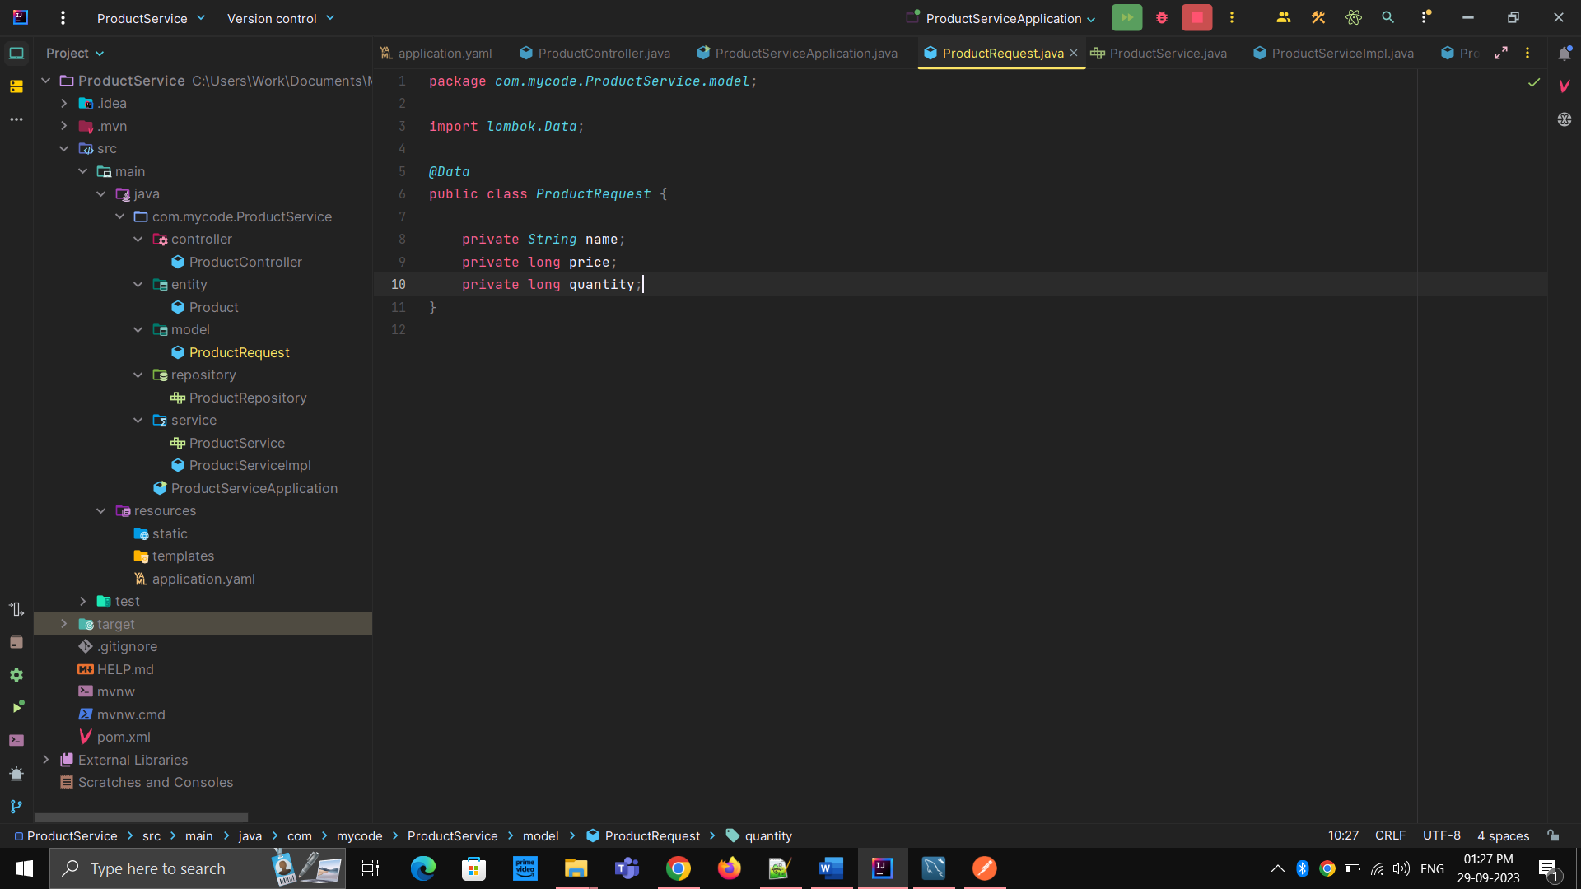

1. Write new method addProduct inside service package

public interface *ProductService* {  
 *Long* addProduct(*ProductRequest productRequest*);  
  
}

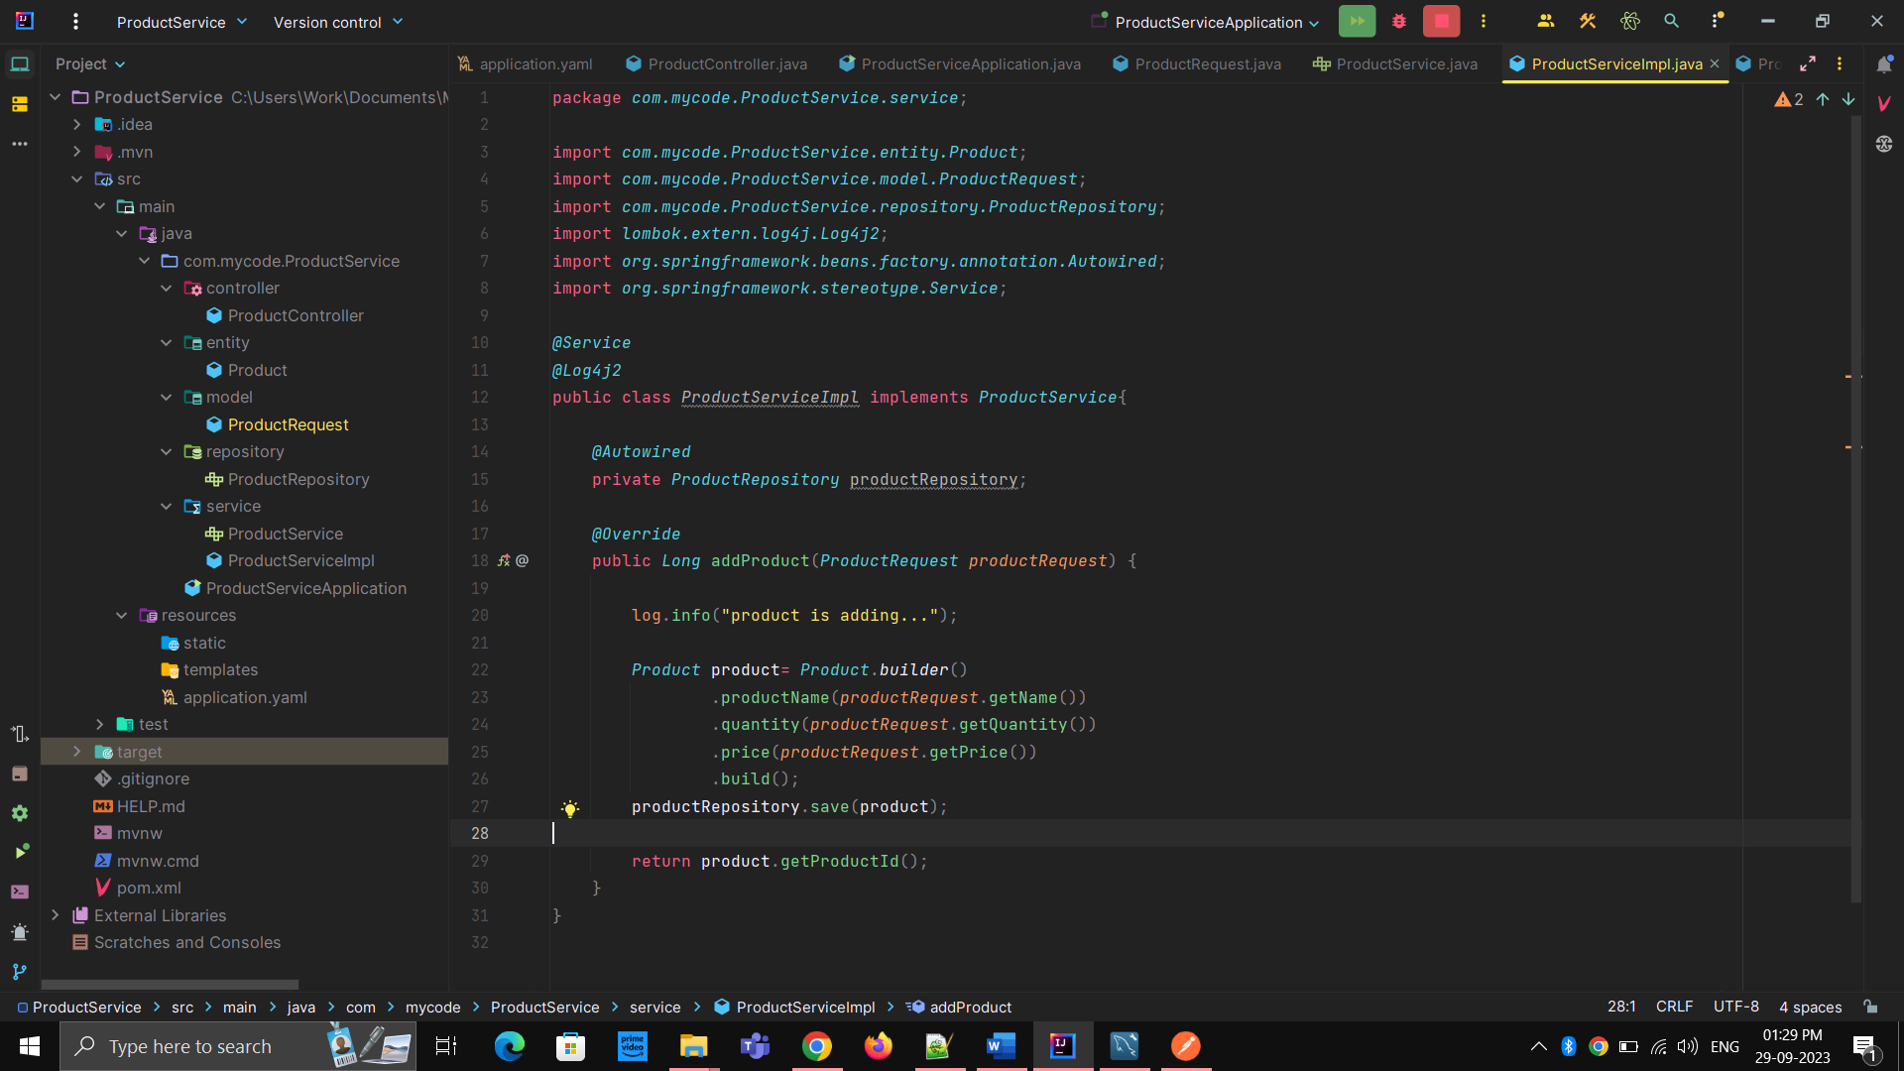

1. Then Run the application
2. Open PostMan <http://localhost:8080/product>
3. Send POST request with the request JSON

{

    "name": "iPhone",

    "price": 64000,

    "quantity": 1

}

Which is from the model package (ProductRequest structure is followed here)